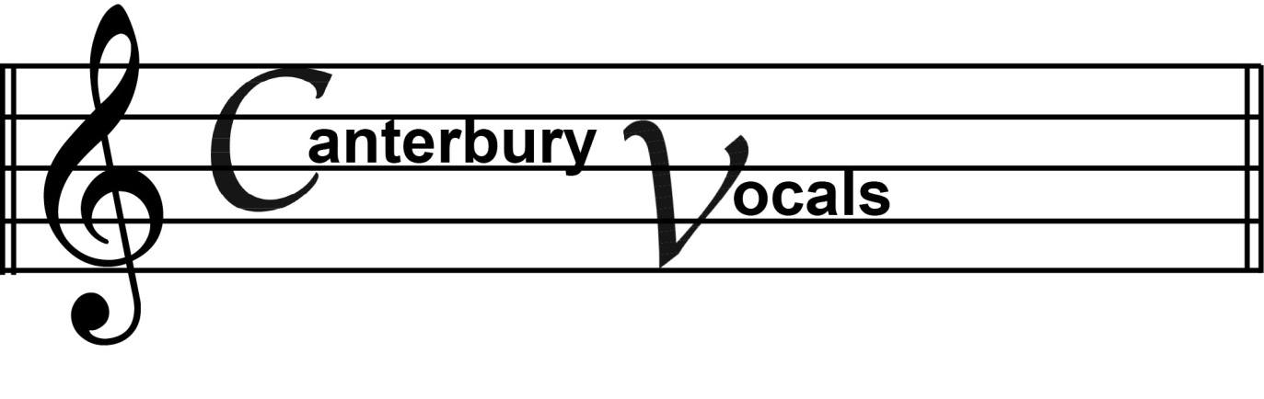

Scholarship Fund for young female musicians

Information Sheet

and

Application Form

The Canterbury Vocals Scholarship Fund was created to provide financial support for young female musicians and help them to achieve their goals and ambitions in music. The fund was established in 2019 to provide financial support for several young musicians each year and has so far helped more than 30 local students. Awards are made to help fund musical activities such as additional lessons, summer schools, masterclasses and special courses or to assist with the purchase of equipment, from music stands and sheet music to music software.

WHO CAN APPLY?
To be eligible to apply, you must be female, aged 18 or under and you must either live, or be attending school or college within a 20 miles radius of central Canterbury. You should already be receiving instrumental or vocal tuition and be able to demonstrate considerable commitment to the further study of music including clearly identified short term and long-term goals.

HOW DO I APPLY?
Applicants should complete all sections of the application form and send with the teacher’s reference to the following address.
Dr Kerry Boyle
Canterbury Vocals
Luton Cottage
Selling
Kent
ME13 9RQ
Tel: 07530 929821
E-mail: kerrymboyle1@hotmail.co.uk

The closing date for applications is 10th July 2026
The Canterbury Vocals Scholarship Fund 2026 - 2027

Application Form
Applicants should complete all sections of this form, including the teacher reference, and send to the following email or postal address no later than 10th July 2025

Dr Kerry Boyle
Canterbury Vocals
Luton Cottage
Selling
Kent
ME13 9RQ
Tel: 07530 929821

E-mail: kerrymboyle1@hotmail.co.uk

Applicant Details
Full Name……….............................................………………… D.o.B ...................…...............
Address..................................................................................................................…............………
Post code ....................……...…… Tel. no ...........................................………
e-mail address …………………………………………………………………..

Name of School or College attended (if applicable) .....................................................……….

Instrument(s) studied (including voice) ...............................................................................

Most recent examination passed (if any). If none, state equivalent Associated Board grade achieved for each instrument.
Instrument………Grade.....Mark.........Date taken...............Exam Board…...................
Instrument………Grade..... Mark........Date taken...............Exam Board.…..................
Instrument………Grade......Mark........Date taken...............Exam Board.…..................

List below any ensembles or music activities (both in school and outside school) which you currently attend and state how long you have been involved in each.
.………....………..................................................................................................................................
……………………………………………………………………………………………………………………………………………………..

Please explain why you are applying for a Canterbury Vocals Scholarship award. For example, what role does music currently play in your life and what are your long-term musical aspirations; how will you use the money if you are successful; how will that help you achieve your long-term ambitions in music; what level of award are you seeking?
…………………………………………………………………………………………………………………………………………………….
.......................................................................................................................................……….....…
........................................................................................................................................………...…
.......................................................................................................................................………....…
........................................................................................................................................………...…
.......................................................................................................................................………....…
……………………………………………………………………………………………………………………………………………………
……………………………………………………………………………………………………………………………………………………
……………………………………………………………………………………………………………………………………………………
……………………………………………………………………………………………………………………………………………………

I understand that my instrumental or singing teacher may be contacted.
Signed................................................. (applicant) Date..................................…
Parent / guardian………………………………………………. Date…………………………

To be completed for all applicants under 18:
I support my daughter’s /ward’s (*) application for a Canterbury Vocals Scholarship Award (* Please delete as appropriate)

Signed............................................ (parent/guardian) Date..............................
Instrumental / Singing Teacher’s Recommendation
This section should be completed by the applicant’s instrumental or singing teacher
Please comment in support of your pupil’s application under the following headings:

Achievements to date
…………………………………………………………………………………………………………………………………………………….
……………………………………………………………………………………………………………………………………………………..
Experience
……………………………………………………………………………………….…………………………………………………………….
……………………………………………………………………………………………………………………………………………………..
Potential
…………………………………………………………………………………………………….................................................
……………………………………………………………………………………………………………………………………………………..
Commitment
…………………………………………………………………………………………………………………………………....................
……………………………………………………………………………………………………………………………………………………..

Any further comments
……………………………………………………………………………………………………………………………………………………
……………………………………………………………………………………………………………………………………………………

Name, address and contact details

Name ……….............................................

Address..................................................................................................................….........
Postcode ..........................

Tel. no .......................
E-mail……………………...............…........……

Signed................................................. Date.......................

